A261-Ushabti-Third Intermediate Period, 21st Dynasty, 1069-945 BCE

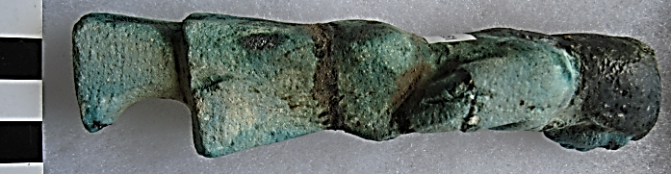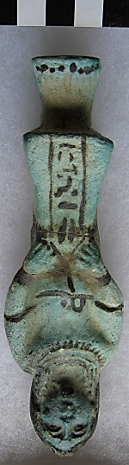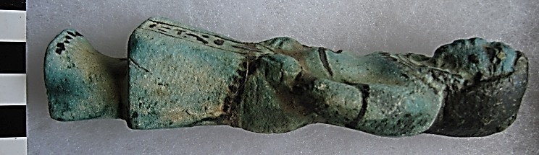

**Case No.: 2**

**Formal Label:** Ushabti Third Intermediate Period, 21st Dynasty, 1069-945 BCE

**Display Description:** Woman in the dress of daily life, with a duplex necklace, a bodice over a blouse and a square skirt of the day. She wears a duplex wig, has her hands on her skirt which is the ancient attitude of praying. This Ushabti is probably from Thebes -- Dayr al-Bari (Deir el-Bahari) (Arabic, الديرالبحر=Shrine of the Great Water (Nile). The temple complex was focused on Hatshepsut’s *Djeser-Djeseru* or "the Holy of Holies," her Mortuary Temple. The hieroglyphs on the skirt present the wearer.

**Accession Number: A261**

**LC Classification:** DT62

**Date or Time Horizon:** Third Intermediate Period, 21st Dynasty, 1069-945 BCE

**Geographical Area: probably** Dayr al-Bari**, Thebes**

**Map, GPS Coordinates:** [25°43′14″N 32°36′37″E](https://tools.wmflabs.org/geohack/geohack.php?pagename=Thebes%2C_Egypt&params=25_43_14_N_32_36_37_E_type:landmark)

**Cultural Affiliation:** Third Intermediate Period, 21st Dynasty

**Medium:** blue faience

**Dimensions: H 153.35 cm; 6.038 in  
Weight: 169 gm, 5 7/8 oz**

**Provenance:.**

**Condition: original, crack in middle of skirt**

**Discussion:** Dayr al-Bahri (Arabic: الدير البحري ad-dayr al-baḥrī = "Monastery of the Sea") is a complex of mortuary temples and tombs located on the west bank of the Nile, opposite the city of Luxor, Egypt. This is a part of the Theban Necropolis.

[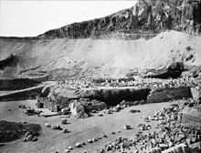](https://en.wikipedia.org/wiki/File:S10.08_Deir-El-Bahari,_image_9935.jpg)

Deir el-Bahari

The first monument built at the site was the [mortuary temple](https://en.wikipedia.org/wiki/Mortuary_Temple_of_Mentuhotep) of [Mentuhotep II](https://en.wikipedia.org/wiki/Mentuhotep_II) of the [Eleventh dynasty](https://en.wikipedia.org/wiki/Eleventh_dynasty_of_Egypt). It was constructed during the 15th century BC.

During the [Eighteenth dynasty](https://en.wikipedia.org/wiki/Eighteenth_dynasty_of_Egypt), [Amenhotep I](https://en.wikipedia.org/wiki/Amenhotep_I) and [Hatshepsut](https://en.wikipedia.org/wiki/Hatshepsut) also built extensively at the site.

**References:**